**Manual to get Windows on your laptop/ Pc**



**Session 2022-2026**

**Submitted By:**

Fiza Amjad 2022-CS-172

**Supervised By:**

Mr. Numan Shafi

Department of Computer Science

**University of Engineering and Technology**

**Lahore Pakistan**

**Steps**

**1- Copy data from C drive to D drive**

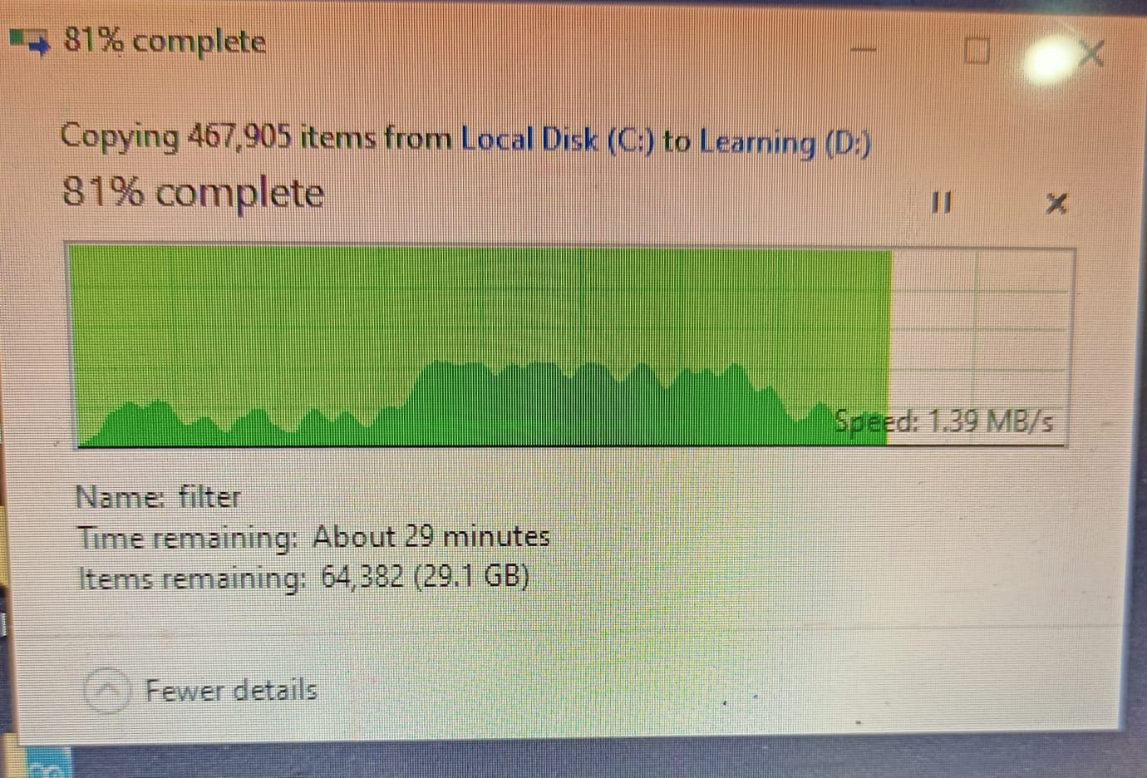

**2- Download ISO file of windows 10**

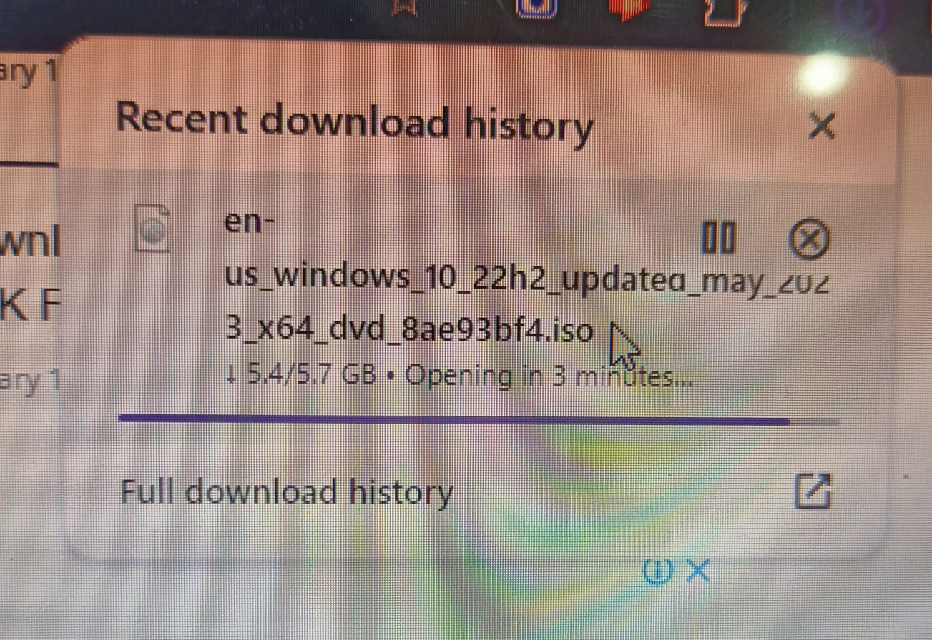

**3- Download Rufus Software from first link that will make our ISO file bootable**

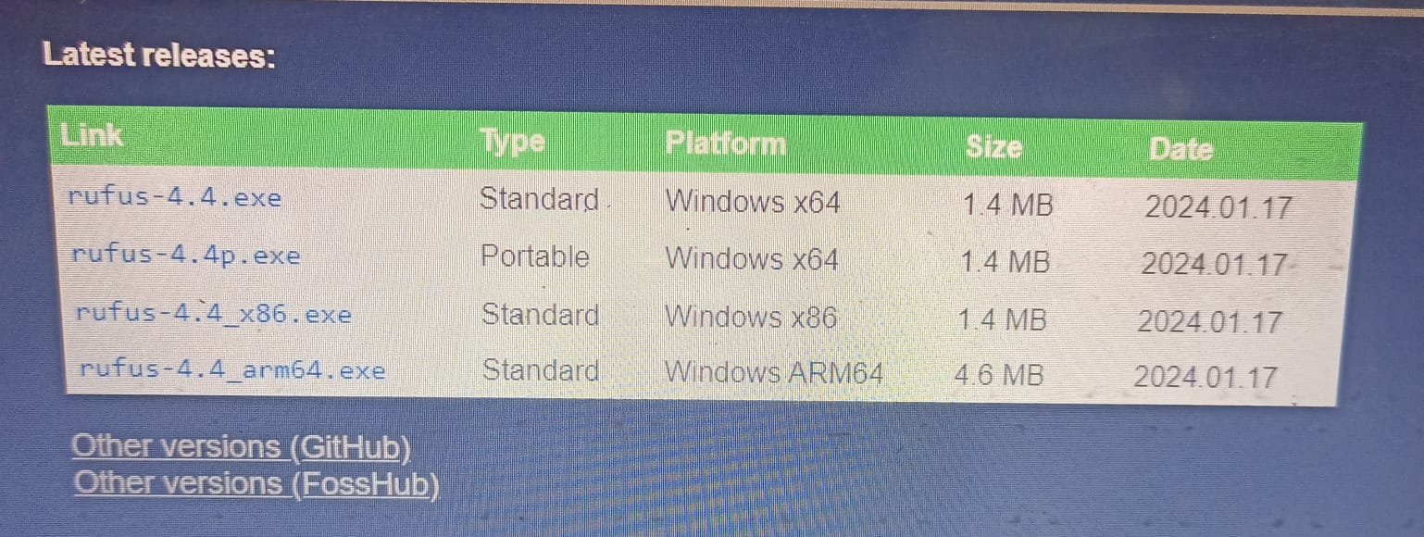

**4- Click on the Rufus Software after downloading**

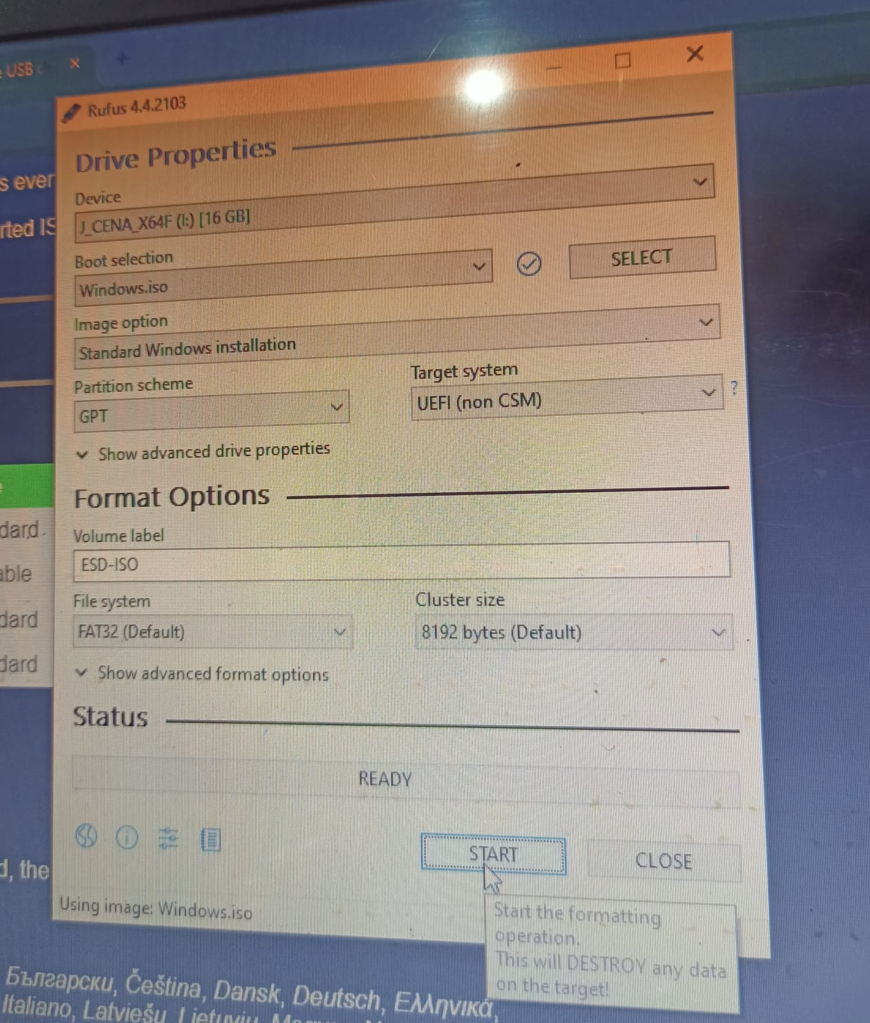

**5- Copy our bootable ISO file through Rufus to USB**

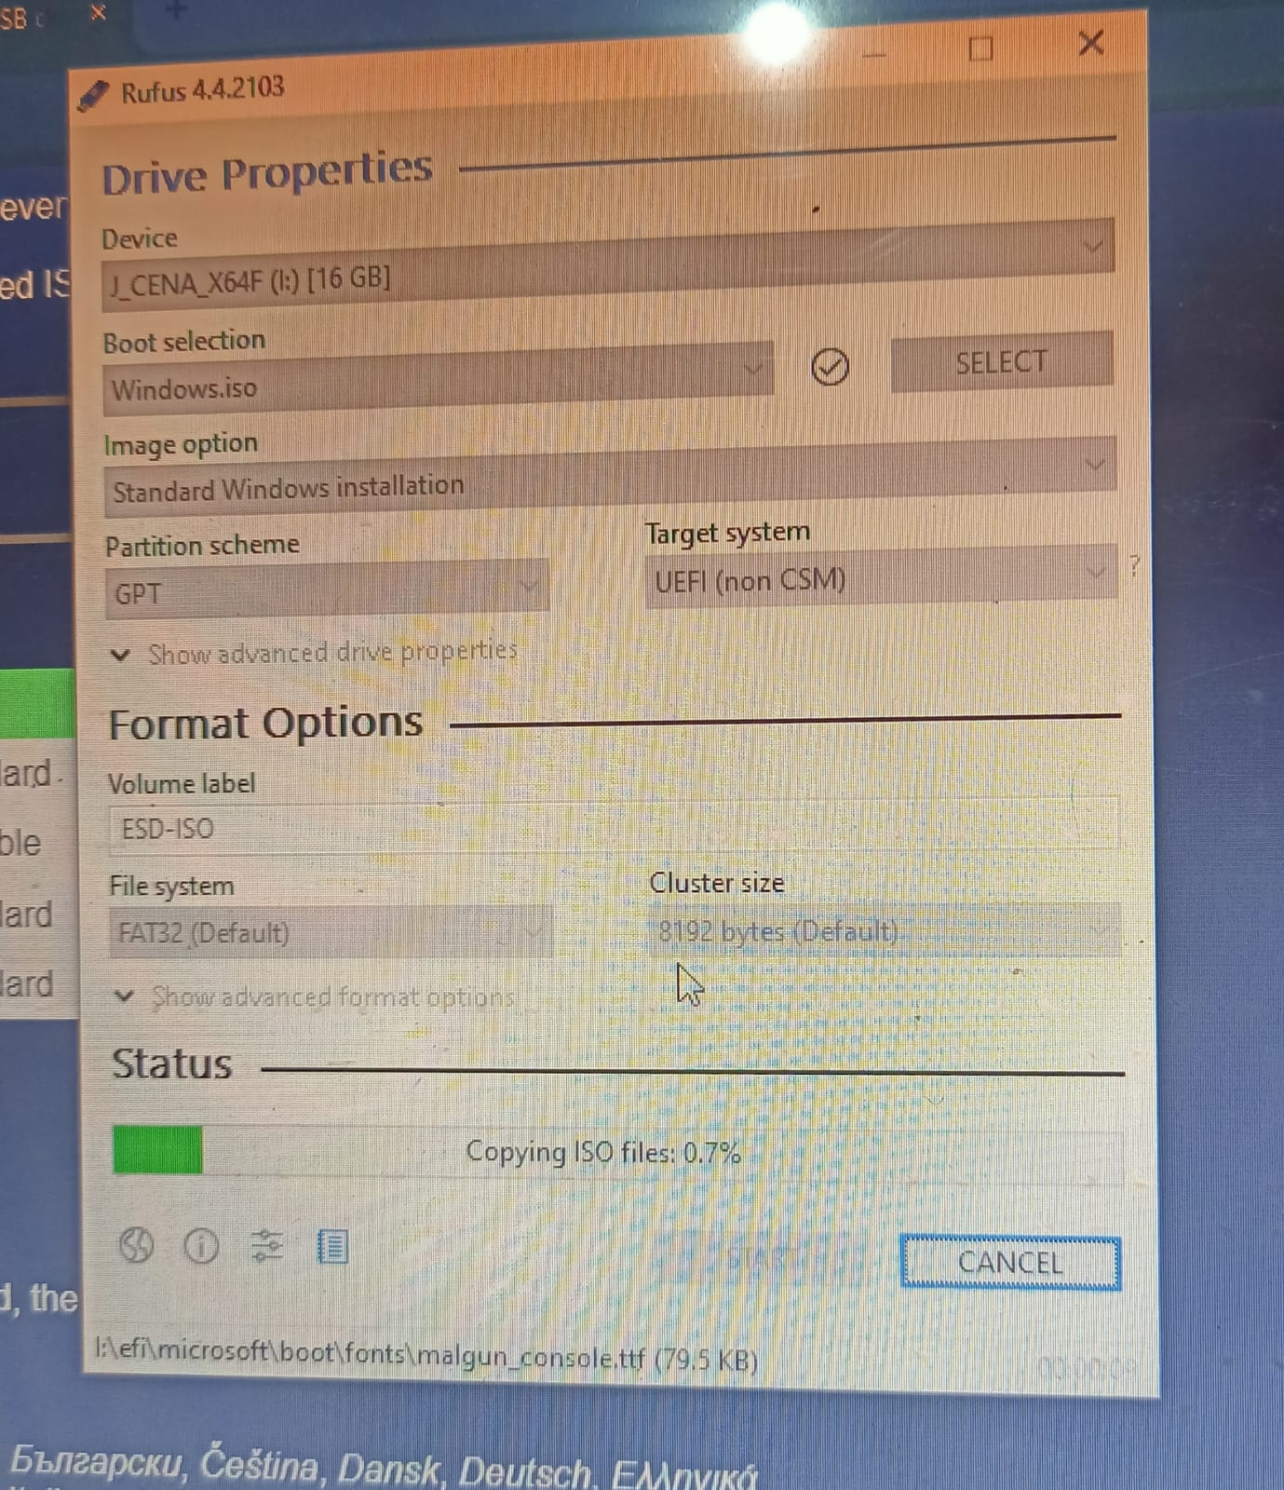

**6- Connect the USB to your DUMP PC and select bios setup option**

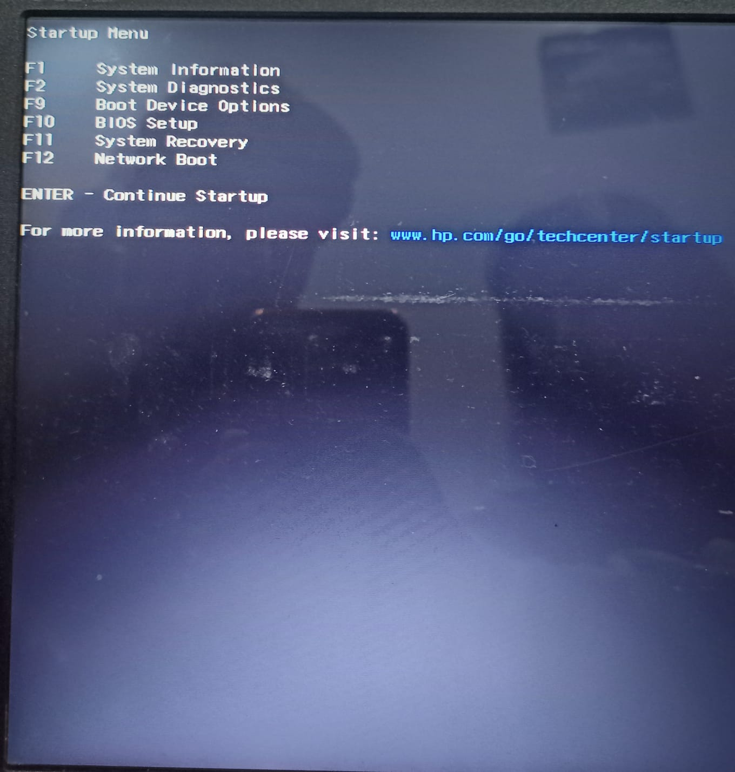

**7- Select Your connected USB option**

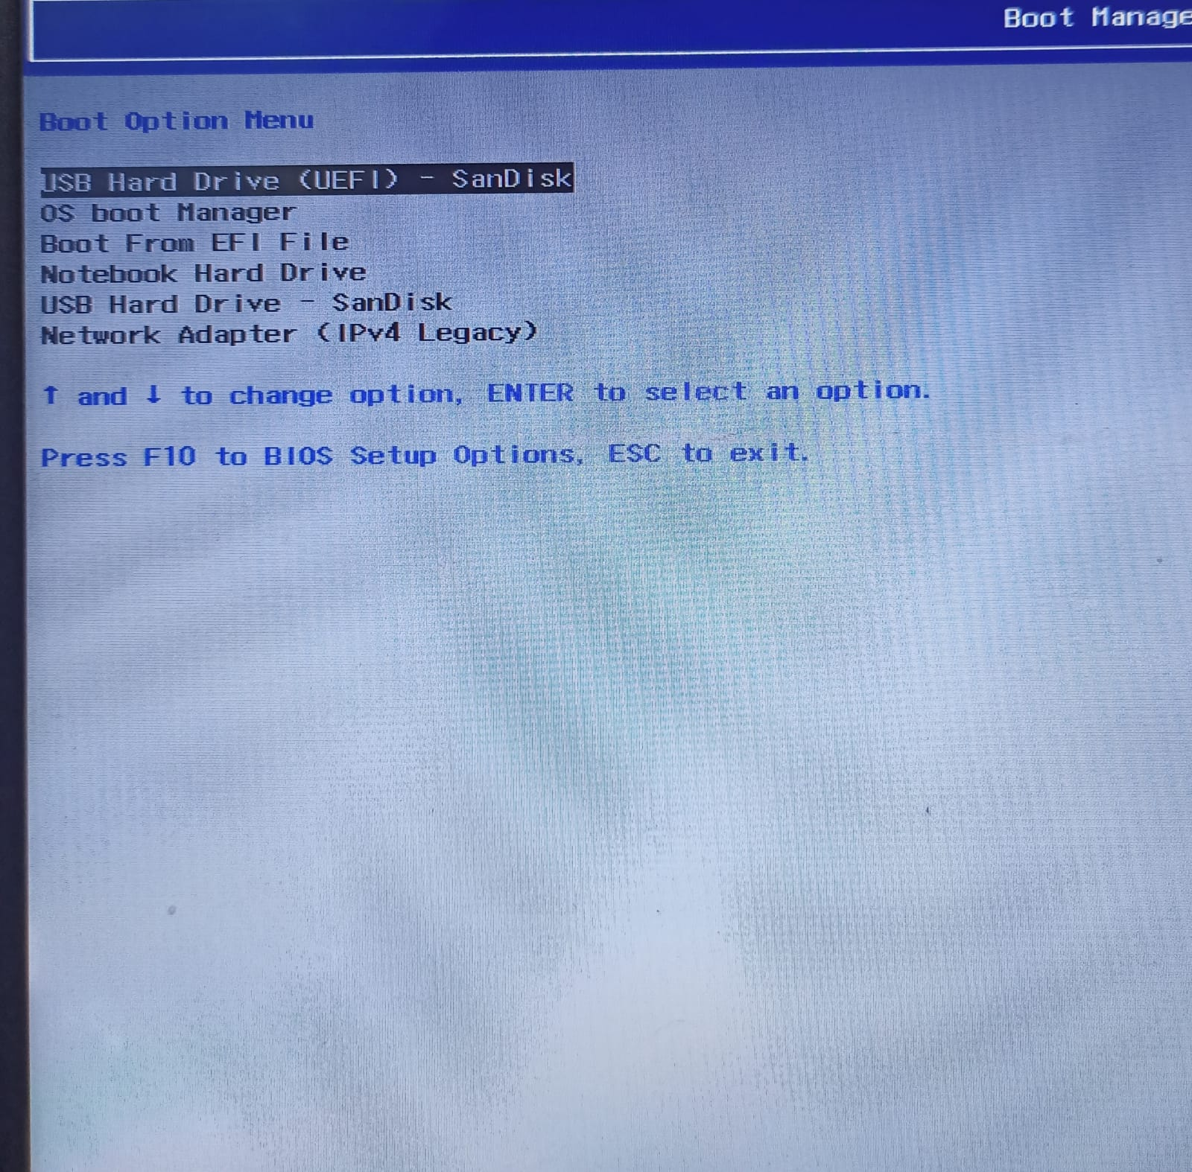

**8- Select windows type**

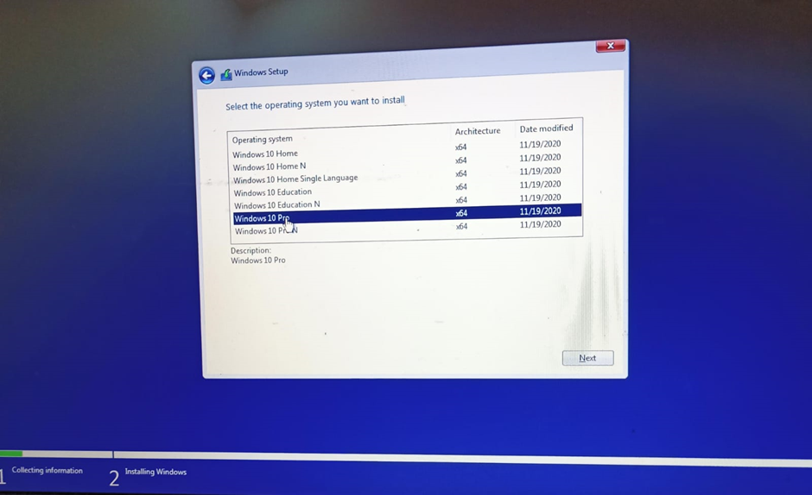

**9- Select the partition and Click on Ok** 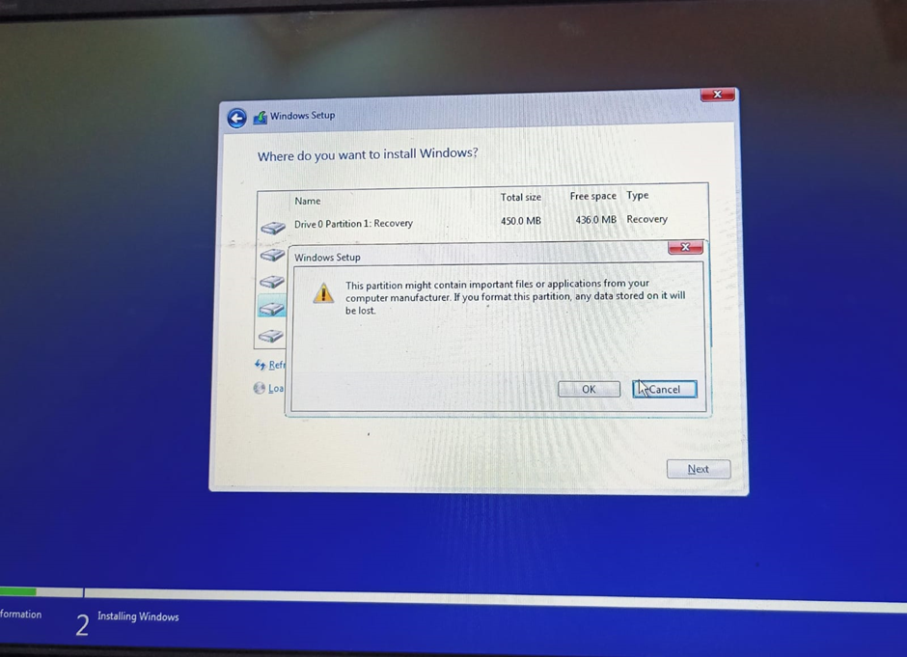

**10- Install the windows**

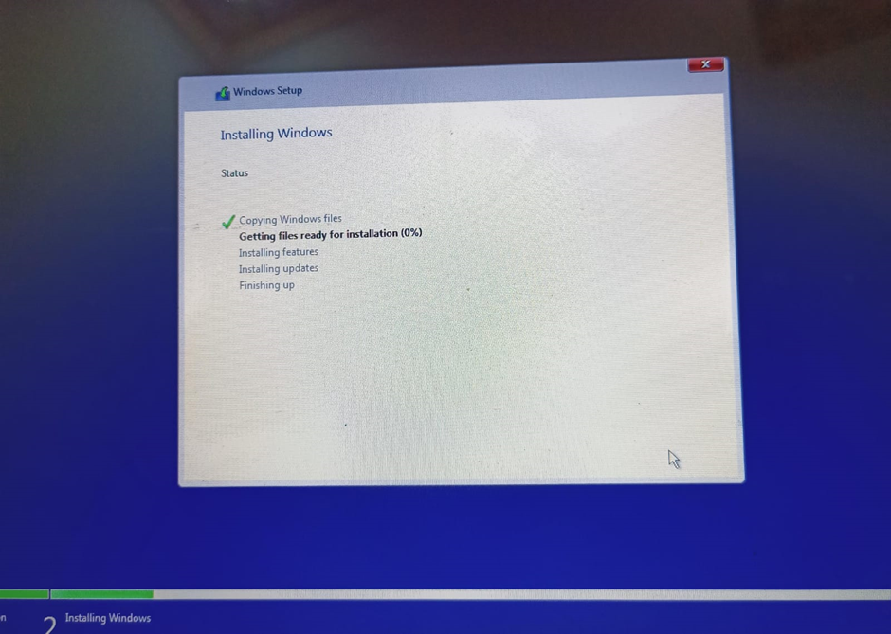

**11- Do the necessary actions i.e. Select the language**

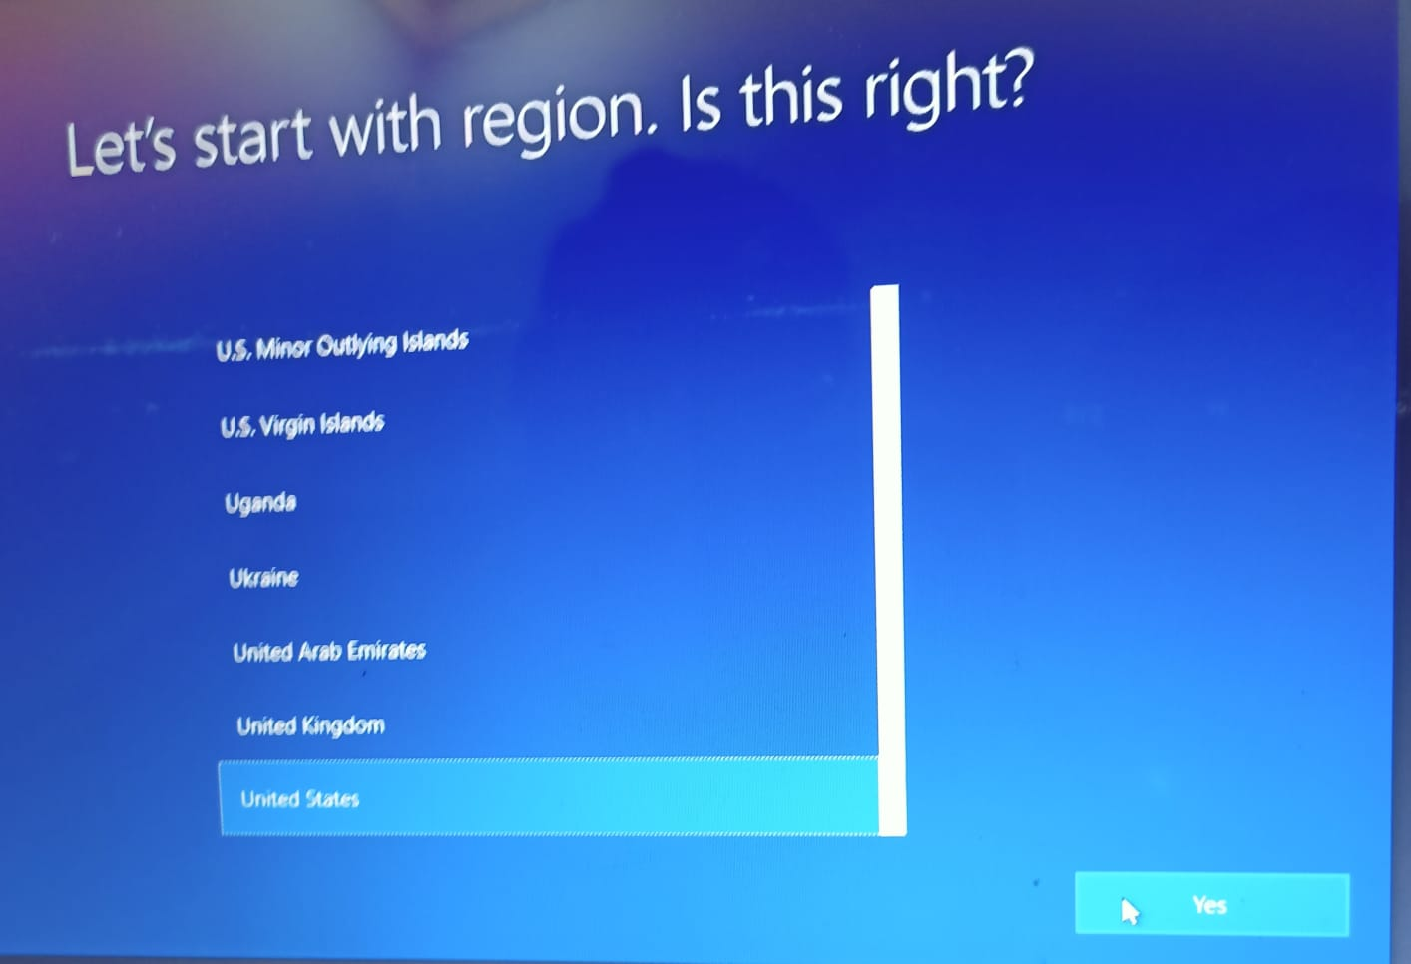

**12- Use it**